BTEC LEVEL 2 FIRST AWARD IN CHILDREN’S PLAY, LEARNING & DEVELOPMENT

UNIT 1: PATTERNS OF CHILD DEVELOPMENT

Exam date:
Thursday 10th Jan 2019 (PM)

Name: ________________________

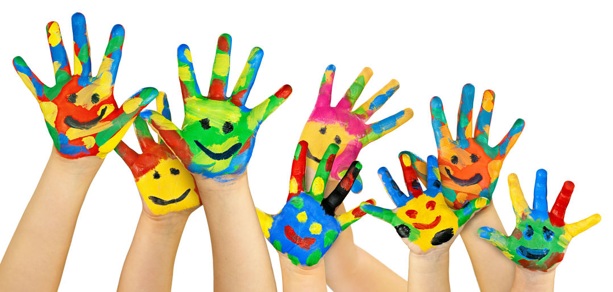

UNIT 1: PATTERNS OF CHILD DEVELOPMENT

This unit is assessed by an exam, which is 1 hour long. The exam date is shown on the front of this booklet.
The exam will contain three types of questions:
- Multiple choice
- Short answer questions (1 or 2 marks)
- Long answer questions (up to 8 marks)

This booklet contains all of the information you need to learn to pass this exam. The unit is divided into three learning aims:
- Learning Aim A: Understand growth and development in children.
- Learning Aim B: Understand the characteristics of children’s development from birth up to 8 years.
- Learning Aim C: Understand how adults in early years settings can support children’s development

In this booklet there are tasks for you to complete as we work through the unit. It is important that you complete all of these so that you have all the correct information you need to revise from.

TOP TIPS FOR EXAM SUCCESS!
- Complete as many practise exam questions as possible so you get used to the way the questions are written
- Learn all of the key words in this booklet (highlighted in green). You may want to make some revision cards
- In the exam, read the questions very carefully before you answer
- Try to attempt all questions even if you’re not sure – you may gain an extra mark which could make the difference between a pass or merit!
LEARNING AIM A:
Understand growth and development in children
Growth happens because certain cells in the body keep dividing. This division of cells means that during childhood children increase in height and weight. Their bones become longer and so their skeleton changes. Growth also affects the development of muscles and the brain.
How growth is measured
- From birth onwards, children are regularly measured by Health Visitors.
- Their height, weight and head circumference are measured.
- The results are marked on to a centile chart.
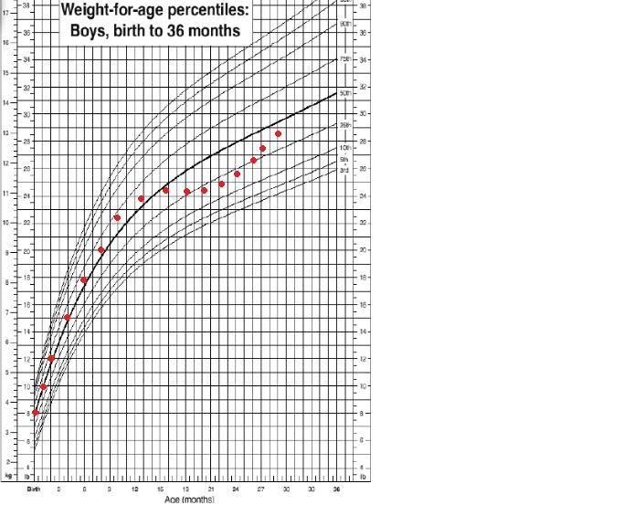
This graph shows how much the child has grown and whether the growth is even.
It also has bands showing where the child’s growth is compared to other children of the same age.
If a child is not growing as expected, it can be a sign of medical problems or that the child is not eating the right amount or type of food.
KEYWORDS
GROWTH: The division of cells
CELL: A tiny part of the body
HEALTH VISITORS: Health professionals who advise families with children
HEAD CIRCUMFERENCE: The measurement of the head from above the eyebrows to around the back of the head
CENTILE CHART: A chart on which measurements are marked and compared with those of other children of the same age.

Factors affecting growth
There are many factors that can affect a child’s growth.
TASK: Can you match the factor to the correct description?

Heredity

Hormones

Nutrition

Sleep
Illness
Emotions
Children who are often ill may not grow well. This is because they may not feel like eating or they might not sleep well. Some diseases affect the digestion of nutrients.
During sleep, hormones for growth are made. Babies sleep 12-14 hours a day and young children 10-12 hours. Children who don’t sleep well may have uneven growth.
The genes that a child inherits from their biological parents will affect their overall height. Some medical conditions that affect growth can also be inherited.
When children are unhappy for a long period of time, it can affect how they eat and sleep and they may become ill. Being unhappy can therefore affect their growth.
The body needs energy to grow. It also needs a wide range of nutrients to keep the muscles, bones and organs healthy. Nutrients are also key to a child’s growth.
These chemicals act as messengers and tell cells when to divide. At certain stages in children’s lives, an increase in hormones will cause them to grow faster, eg: puberty.

KEYWORDS
HORMONES: Chemicals that can make cells divide which leads to growth
NUTRIENTS: Substances found in food that are important for health and growth

Development
Holistic development
When health professionals and early years staff look at children’s development, they tend to look at the whole picture of what a child can do – this is called holistic development.
Children will develop some skills faster than others, eg: a 3 year old may be able to name three colours but can’t yet kick a ball.

Norms of development
- When a baby starts to crawl or when a child can say their name, these are special moments in their development. These are called milestones.
- For every age group there is a list of milestones that most children will meet. These are the developmental norms. These norms are based on what most children are able to do at a particular age.
- A child’s progress is assessed using the milestones for their age. Knowing about the milestones for each child can help you to plan activities and spot children who may need more support.
KEYWORDS
MILESTONES: Skills or knowledge that a child has learnt.
DEVELOPMENTAL NORMS: The milestones associated with a certain age group.

Five key areas of development
Physical
Cognitive

Areas of development
Communication & language
Emotional & behavioural

Social

TASK: Match up the area of development with the correct description.
Physical development

Cognitive development

Communication and language development
Emotional and behavioural development
Social development

This is about the way that our brains take in information.
This is about our relationships with other people.
This is about the way that children move and use their bodies.
This is about being able to understand what others say and being able to speak.
This is about how children develop feelings and concern for others.

Physical development
Physical development is divided into gross motor movements and fine motor movements.
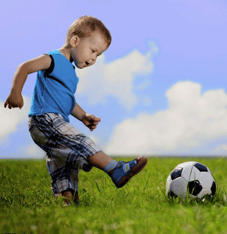
Gross motor movements involve use of the arms and legs, eg: kicking or throwing.
As part of gross motor movements, children learn to be mobile (walking/crawling). These are called locomotive movements. They involve balance and co-ordination.
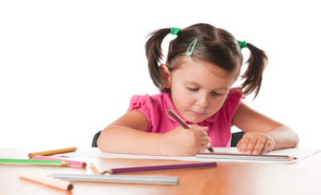
Fine motor movements are usually about the hands and involve many skills, such as hand-eye co-ordination. This is where the hands and eyes work together, for example, in handwriting or sewing.
Children’s hands also have to develop strength and a range of movements called fine manipulative movements, which are quite complex skills.
Being able to turn the lid of a bottle is an example of this, as is the tripod grasp (sometimes known as the pencil grasp).
TASK: Can you think of 2 examples of gross motor movements and fine motor movements?
Gross motor movements: Fine motor movements:
______________________________ ________________________________
______________________________ ________________________________
KEYWORDS
GROSS MOTOR MOVEMENTS: Large movements of the arms and legs.
FINE MOTOR MOVEMENTS: Small movements usually associated with the hands.
LOCOMOTIVE MOVEMENTS: Skills involved in crawling, walking, running and being mobile.
HAND-EYE CO-ORDINATION: Where eyes and hands work together to manage a task.
TRIPOD GRASP: A pencil hold where the finger and thumb hold the pencil supported by the middle finger.

Cognitive development
- Cognitive development is about how our brains take in information – this is called perception.
- It is also about how we remember and think about the information we have taken in.
- Cognitive development is linked to imagination, problem-solving and our understanding of number, colour and shape.

Communication and language development
- Communication and language development is about being able to understand what people say to us.
- It is also about being able to speak and make yourself understood.
- Communication and language development is involved in learning to read and write.

Emotional and behavioural development
- Emotional development is about how children develop feeling and concern for others.
- It is also about how they learn to express their emotions, such as anger or excitement, appropriately.
- Emotional development also includes how we view ourselves (this is called self-concept) and whether we value ourselves (this is called self-esteem).
Social development
- Social development is about our relationships with other people.
- It is about friendships with other children and also the skills needed to maintain relationships, such as being thoughtful and learning to be part of a group.
- Children often learn these skills by watching role models, eg: parents, teachers or older siblings.
KEYWORDS
PERCEPTION: The ability to become aware of something using the senses.
SELF-CONCEPT: How we view ourselves.
SELF-ESTEEM: How much we value ourselves.
ROLE MODELS: People from whom children copy behaviour and attitudes.

Links between areas of development

Links between areas of development
It is important to think about how each of these areas of development can affect each other. For example, a difficulty or delay in one area of development can affect other areas.
Communication and language development

Physical development

Cognitive development

Emotional and behavioural development

Social development

LEARNING AIM B:
Understand the characteristics of children’s development from birth up to 8 years

Early years professionals need to know the usual patterns of each of the 5 areas of development. This is because they need to consider whether children are meeting the milestones for their age group.
However, milestones are only a guide – as there are many factors that can affect growth and development, some children will develop faster than others.

Sequences of development
Often certain milestones have to be reached before others can be achieved.
For example:
- Children need to learn to walk before they can run.
- Children have to know words before they can speak them.

TASK: Place the numbers 1 to 4 in the boxes below to show the usual sequence in which babies learn to walk.
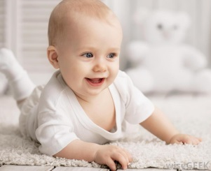
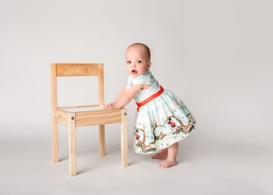

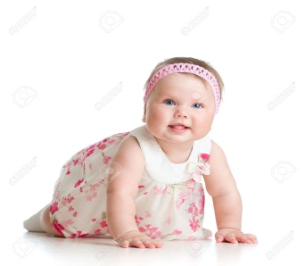
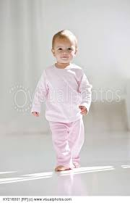
Standing, supported Holding head up

Walking, unsupported Crawling
Birth up to 12 months
Physical development
- Development in the first year is fast.
- Babies are born pretty much helpless. They rely on some reflexes in order to survive.
- These include the reflex to suck and find food, which is called rooting.
- They also grasp tightly to things and respond to sudden sounds with a startle reflex by flinging out their arms.
- Babies can’t control these reflexes. Over time, these reflexes disappear and they learn to control their movements instead.
- This begins with control of their head, followed by their arms and legs until they finally develop some hand-eye co-ordination.
KEYWORDS
REFLEXES: Instinctive movements in babies, including startle, sucking, rooting and grasping.
ROOTING: Instinctive movement that helps babies to find the breast or bottle’s teat.
STARTLE REFLEX: Instinctive movement when babies fling out their arms in response to sudden sounds or movements.

TASK: Match up the gross motor movements to the correct age.
1 month

3 months

6 months

9 months

12 months

- When lying on back, can roll over to front

- Can sit up unsupported
- Likely to be crawling, rolling or shuffling
- Starting to pull up to a standing position by holding on to furniture
- Can pull up to standing easily
- May be standing alone and walking holding on to furniture
- Can lift head and chest up when lying on stomach
- When lying on back or being held, can bring hands together
- Moves head from side to side

TASK: Match up the fine motor movements to the correct age.
1 month

3 months

6 months

9 months

12 months

- Interested in watching their hands
- Can hold a rattle for a few seconds
- Can pick up very small things using a pincer grasp
- Points to objects using index finger
- Can reach out for a small toy and move it from one hand to another
- Can grab things using their index finger and thumb (pincer grasp)
- Can deliberately drop things such as a spoon
- Range of reflexes appear, eg: swallowing and breathing which are permanent. Others will disappear over the next few months
- Will grasp things that are put into their hands as a reflex action

KEYWORD
PINCER GRASP: Using finger and thumb to hold a small object as if pinching.

Cognitive development
- In the first year, babies are learning about their new world.
- Their brains are taking in a lot of information that has to be processed.
- Some believe that is why they need to sleep so much.
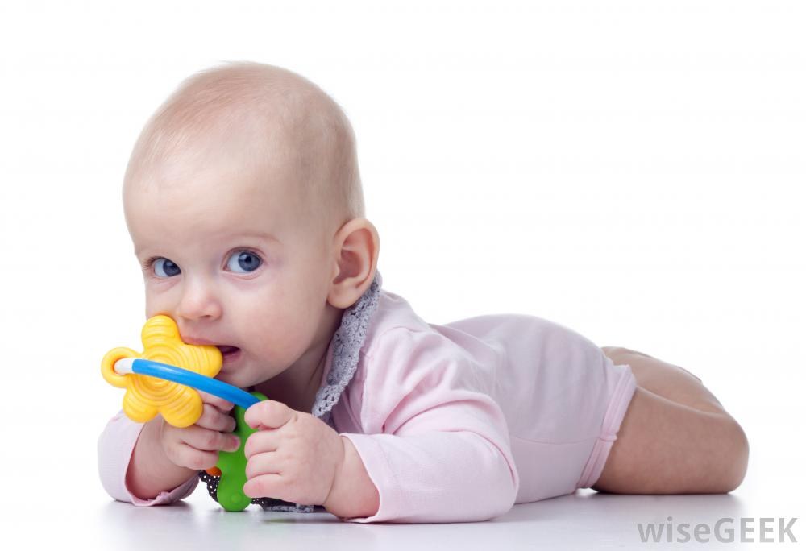
KEYWORDS
MOUTHING: Putting items in the mouth as a way of exploring them.
TRIAL AND ERROR LEARNING: Learning by trying things out and repeating if successful.

TASK: Match up the cognitive abilities to the correct age.
1 month

3 months

6 months

9 months

12 months

- More alert
- Will follow movement of objects if they’re close by
- Recognises parts of familiar routines – eg: will get excited on hearing sound of water for a bath
- Enjoys dropping things to the ground and watching them fall
- Will repeat actions if enjoyable and interesting – this is called trial and error learning
- Freezes on hearing a soft sound, such as a tune from a cot mobile
- Explores objects by handling them and mouthing them.
- Recognises voices
- Begins to look for things that are put out of sight

Communication and language development
- In the first year, babies are trying to tune in to sounds they are hearing.
- They need to tell the difference between human voices and other sounds.
- They also need to learn what words mean.
- Babies also make sounds in their first year, which by 12 months sound almost like words.

TASK: Match up the communication and language abilities to the correct age.
1 month

3 months

6 months

9 months

12 months

- Makes short babbling sounds like ‘ba’ and ‘pa’.

- Understands the word ‘no’.
- Starts to make strings of babbling sounds such as ‘dadadada’
- Turns head when hearing a familiar adult voice
- Starts to make cooing sounds
- Smiles or shows signs of recognising own name
- Follows very simple instructions like ‘Where’s daddy?’
- Smiles on hearing a familiar voice

Emotional and social development
- From a very early age, babies look at faces and eyes. They also like to be held.
- For the first few months, babies will smile and enjoy being held by anyone – this is known as indiscriminate attachments.
- From about 7 months, they start to want to be with the important people in their lives, such as their parents – these are called specific attachments.
KEYWORDS
INDISCRIMINATE ATTACHMENTS: Where babies show affection and can be cuddled by people they don’t know.
SPECIFIC ATTACHMENTS: Where babies and young children show affection and can only be cuddled or reassured by their primary carers, eg: parents.
PRIMARY CARERS: People who have a key role in a child’s life, often – but not always – the child’s parents.
SEPARATION ANXIETY: Panic and distress shown when a child can’t see or be with their parents or people they are emotionally close to.

TASK: Match up the emotional and social abilities to the correct age.
1 month

6 weeks

3 months

6 months

7-8 months

8 months

- Enjoys being held
- Shows indiscriminate attachments
- First signs of specific attachment – cries if held by someone they don’t know
- Smiles at primary carers and wants to be held by them
- Specific attachments fully formed.
- Separation anxiety – babies may cry when left alone or with people they don’t know
- Enjoys copying actions of others, eg: clapping.
- Stares at human faces with interest
- Wants to be held
- Starts to smile and respond to smiles
- Can recognise emotions in others, eg: angry tone of voice, and responds to them.

12 months up to 3 years
Physical development
- Children usually become mobile in this period and learn to walk.
- They also learn to co-ordinate their movements which allows them to do more things, such as picking up small objects.
- Children also become toilet trained in this period, usually between the ages of 2-3 years old.
TASK: Match up the gross motor movements to the correct age.
15 months

18 months

2 years

2 ½ years

3 years

- Can run.
- Enjoys climbing and may climb on furniture.
- Can use a sit-and-ride toy and love using feet.
- Can crawl upstairs.
- Can stand and may be walking by holding on to furniture.
- Can run forwards and backwards.
- Can steer and pedal a tricycle.
- Walks upstairs using alternate feet for each step.
- Can aim and throw a large ball.
- Can walk without any help.
- Can walk upstairs holding on to a rail or hand.
- Can squat down to pick up a toy.
- Can kick a large ball.
- Can jump with two feet from a low step.

TASK: Match up the fine motor movements to the correct age.
15 months

18 months

2 years

2 ½ years

3 years

- Has enough control to draw dots and circles with a crayon.
- Can put on and fasten Velcro shoes.
- Tripod grasp is used when holding a pen/pencil.
- Hand preference is set.
- Uses a pincer grasp to pick up small objects.
- Holds crayons by wrapping hand around them – this is called the palmer grasp.
- Has enough hand-eye co-ordination to build a tower of 3 bricks.
- Can feed self easily with a spoon.
- Hand preference is starting to be seen.
- Can pull down items of clothing such as trousers.
- Beginning to use a tripod grasp.

KEYWORDS
PALMER GRASP: Wrapping the whole hand around an object to make a movement.
HAND PREFERENCE: The hand that is most often used for tasks requiring hand-eye co-ordination and which will become the hand used for writing.

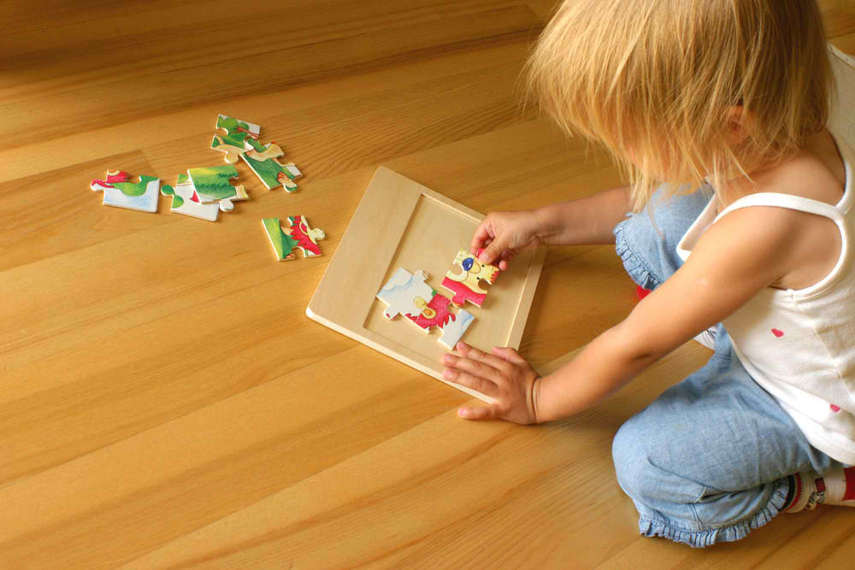
Cognitive development
- During these two years, children are keen to explore and learn more about their world.
- They start to show they remember things.
- They also develop language skills, which is linked to their cognitive development.

TASK: Match up the cognitive abilities to the correct age.
15 months

18 months

2 years

2 ½ years

3 years

- Very curious and likes to explore objects and how they work.
- Remembers where objects go, eg: will get a spoon from a drawer or put toy back in toy box.
- Can point to a photo of self.
- Can complete a simple puzzle with some help.

- Starts to understand the difference between past and present.
- Can complete a puzzle with 12 pieces.
- Interested in the sight and sound of objects and keen to explore.
- May still explore objects by putting them in their mouth, but less than before.
- Recognises self in a mirror and knows this is not another child!
- Can remember things that have happened in the past – eg: remembers actions, toys and people.

Communication and language development
- Children’s communication and language skills develop quickly in this period.
- At 18 months they start saying a few words.
- Between the ages of 2-3 years, children learn and start to say several new words each week.
- They also start to put words together into sentences.
- By the age of 3, most children love to chatter!

TASK: Match up the communication and language abilities to the correct age.
15 months

18 months

2 years

2 ½ years

3 years

- Children will have at least 15 words.
- Can communicate their wishes using words and actions.
- Understands simple requests, eg: ‘Get your shoes’.
- Speech is clear to anyone who does not know the child well.
- Enjoys books and turns pages.
- Likely to have up to 200 words.
- Uses simple sentences and asks simple questions, eg: ‘What’s this?’.
- Uses personal pronouns, negatives and plurals, eg: ‘I don’t want bricks’.
- Communicates by pointing and also makes babbling sounds.
- Will have up to 6 words.
- Children will have 50 words or more.
- Starts to join words into two-word sentences, eg: ‘Ball gone’.
- Enjoys looking at books.

KEYWORDS
PERSONAL PRONOUNS: Words like ‘it’, ‘she’, ‘he’ and ‘they’ which replace someone’s name.
NEGATIVES: A way in speaking and writing of saying something is not the case, by using the words ‘not’, ‘no-one’ and ‘nothing’, eg: ‘I am not tired’.
PLURALS: A way in speaking and writing of saying there is more than one object or person, by adding an ‘s’ to a words, eg: ‘dogs’.

Emotional and social development
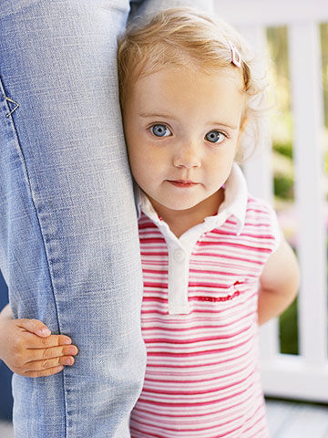
- Children’s emotional and social development happens at a slower pace.
- Once they learn to speak fluently, this will speed up.
- At this age, children like to be near the people they care most about. They can become upset and show separation anxiety if they are not with them.
- They are often unsure of strangers and may hide or cling to their familiar adult.
- They are often interested in watching other children, but until the age of 3, they will not have the social skills to play with them.

TASK: Match up the emotional and social abilities to the correct age.

18 months

2 years

2 ½ years

3 years

- Plays next to other children and watches or copies their actions (onlooker play).
- Depends heavily on adult attention.
- Jealous of other children getting adult attention.
- Responds well to adult attention and praise.
- Likely to have tantrums if don’t get own way.

- Finds it easier to wait for things.
- Starts to take turns and share with other children.
- Enjoys playing with other children.
- Will comfort other children who are upset.

- Can’t wait for needs to be met and has tantrums.
- Can sometimes be distracted from having a tantrum.
- Plays next to other children but not able to share toys.

- Plays alone but enjoys being near adults, brothers, sisters and other children.
- Needs immediate attention.
- Can copy adults’ actions, eg: throwing a ball.

3 years up to 5 years
Physical development
- In this period, children gain increased skill in both gross and fine motor development.
- They start to be able to talk as they pedal or throw.
- They also start to use their hands to use tools like scissors or knives and forks.
- Some of this development is quite slow so it is harder to separate into months.

Gross motor development
3-4 years | - Can hop on one foot.  - Can walk along a line.  - Can aim and throw a ball fairly accurately.  - Can kick a ball with some force.  - Can ride a tricycle using pedals and steer it accurately.
4-5 years | - Can run and avoid obstacles.  - Can skip with a rope (often nearer 5 years).  - Can throw a large ball to a partner and catch it.

Fine motor development
3-4 years | - Can button and unbutton clothes.  - Uses scissors to cut out simple shapes.  - Can draw a person with a head, body and legs.  - Eats with a knife and fork.  - Can thread beads to make a necklace.
4-5 years | - Can form letters.  - Writes own name.  - Colours in pictures.

Cognitive development
- In this time, children learn to count, put things in order, and learn about time, colours and shape.
- This depends on adults pointing things out to them and also whether their language skills are developed enough to understand these things.

3-4 years | - Can recognise and name primary colours – red, blue and yellow.  - Understands what is meant by ‘more’.  - Can tell if an object is heavy or light.  - Arranges objects into categories.  - Makes connections between people and events.
4-5 years | - Can count up to 10.  - Can add two sets of objects together.  - Can match up equal sets of objects, eg: which two boxes have the same number of beakers?  - Can understand the need for rules.  - Knows the times of day linked with different activities, eg: bedtime is at night.

Communication and language development
- In this time, children’s language becomes fluent, which is important as this is a key way that children will learn.
- They will make some grammatical mistakes but these will become fewer.
- Their communication and language skills help them to play with others.

3-4 years | - Speech can be easily understood, but some words may not be pronounced correctly, eg: ‘wabbit’ instead or ‘rabbit’.  - Uses questions to gain attention, but also out of interest, especially, ‘why’, ‘what’ and ‘how’.  - Fluent speech at 4 years (with some errors).
4-5 years | - Can count accurately up to 10.  - Uses complex sentences with words like ‘because’.  - Can talk about what has happened and what might happen.  - Uses language to argue and answer back.

Emotional and social development
- Having friends becomes very important in this age range.
- Children are also learning to express and control their emotions. They have fewer tantrums unless they are tired.
- Children are also happier to be separated from their primary carer (usually a parent) if they know the adult they are left with.
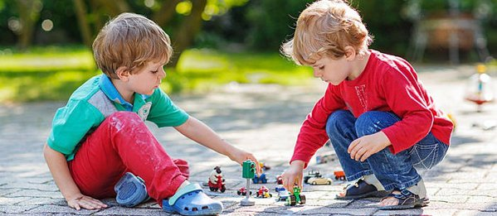

3-4 years | - Can cope with separation from primary carer when they are with someone they know.  - Begin to play co-operatively and enjoy playing with others.  - Shows clear friendship preferences.
4-5 years | - Can work out what others may be thinking – this helps them connect with others.  - Able to understand the need for rules – although they may not always follow them!  - Close friendships develop, and children may be sad if their friend is not there.  - Behaviour is mostly co-operative.  - Separates more easily from their parents.

5 years up to 8 years
Physical development
- Children’s co-ordination continues to improve so they can manage more difficult tasks, like playing ball games or sewing.
- They need lots of opportunities to develop these skills.
- Some children will learn faster than others.

Gross motor development
5-8 years | - Can hop, skip and jump confidently.  - Can run, swerve and dodge.  - Balance is good – can walk on a beam, ride a bike and use roller skates.  - Can combine gross motor skills, so they can often swim and play games like hopscotch or ball games like football and tennis.

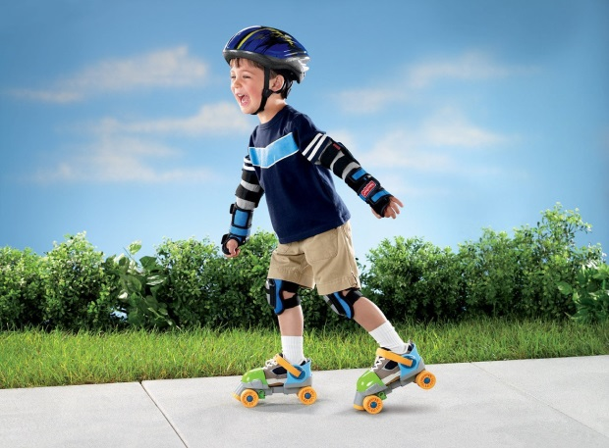
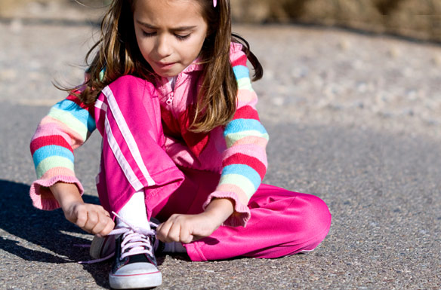

Fine motor development
5-8 years | - Can tie and untie shoelaces.  - Improved scissor skills – can cut out irregular shapes and follow a line.  - From 6 years is able to thread a needle and sew large stitches.  - From 6 years has good control over pencils and paintbrushes.  - From 6 years can draw detailed pictures.  - From 6 years is able to show clear handwriting.

Cognitive development
- In this time, children learn mathematical concepts like time.
- They can also use their language to be logical.
5-8 years | - Can recognise numbers up to 100.  - Can do simple calculations.  - Able to reason and be reasoned with, eg: ‘If I leave my bag here, I will remember it when I go out’.  - From 7 years, can conserve quantities and numbers, eg: recognises that if there are five counters on a plate and they are then arranged in a different pattern there will still be the same number of counters.  - From 7 years, can complete a simple maze showing skills in logic.  - From 7 years, starts to tell the time.  - From 7 years, understands the need for rules and can follow them. Also plays games that involve rules.
KEYWORD
CONSERVE: Ability to understand that a fixed quantity of objects or liquid stays the same even if it is presented differently.

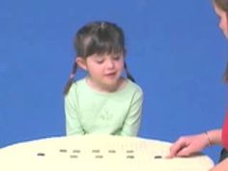
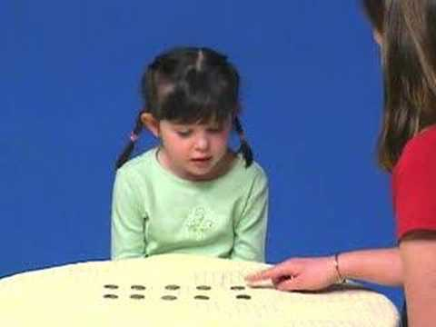

Two rows of 5 counters Two rows of 5 counters - evenly spaced - one row more spaced out

Communication and language development
- The focus in this time period is learning to read and write.
- These skills in turn support children’s cognitive development.

5-8 years | - Uses language and reason to explain ideas.  - Understands and enjoys jokes and riddles.  - Uses more complex sentences and asks ‘what’, ‘where’, ‘when’, ‘who’, ‘why’ and ‘how’ questions.  - From 7 years, has mastered the basics of reading and writing.
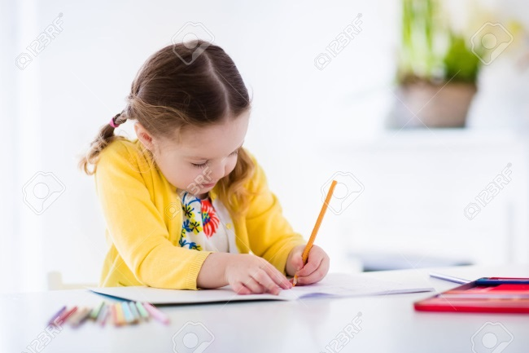

Emotional and social development
- Children become more confident and enjoy their friendships in this period.
- They find it easier to control negative emotions like anger and instead use language to express their feelings.
- Children also find it easier to change their behaviour to fit different social situations – eg: the way they behave inside and outside a classroom.
- Their confidence may change in this period as they start to be more self-aware.

5-8 years | - From 5-6 years, they start to compare themselves to others.  - From 5-6 years, they are more aware of the feelings and needs of others.  - Self-confidence may be shaken by failure.  - From 5-7 years, they have strong friendships, often of the same gender.  - From 5-7 years, they can understand that others can have different views from their own.  - From 5-7 years, they can read facial expressions and recognise what others might be feeling.
LEARNING AIM C:
Understand how adults in early years settings can support children’s development

Adults play an important role in children’s development.
Children benefit when adults meet their all-round needs. This includes physical care, love and attention and also activities and resources to help them learn and play.

How can adults support physical development?
Meet physical needs
- Well-ventilated rooms to prevent germs.
- Opportunities to sleep.
- Keep them safe and healthy.
Meet dietary needs
- Aware of food allergies.
- Regular food and drinks to help concentration.
- Maintain a healthy weight.

Encourage gross & fine motor skills
- Range of activities should be provided to develop skills, eg: using scissors or throwing balls.
- Should be appropriate for age range.
Provide outdoor opportunities
- Fresh air and exercise are important for health.
- Increases Vitamin D, bone strength and heart and lung development.

Teach self-help skills
- Children need to learn to wash their own hands, feed themselves and go to the toilet.
- Need to show them and give praise.
Provide sensory opportunities
- Provide a range of materials with different textures, eg: sand, play dough and water.
- Helps develop fine motor skills.

KEYWORD
SENSORY: Sensory materials are resources that feel interesting and which children can explore, such as sand and play dough.

TASK: List 5 specific things an adult can do to support a child’s physical development.
- ______________________________________________
- ______________________________________________
- ______________________________________________
- ______________________________________________
- ______________________________________________

How can adults support cognitive development?
Encourage problem-solving
- Provide toys, games and puzzles that help to develop children’s problem-solving skills, eg: jigsaw puzzles.

Develop memory & imagination
- Play games to help with memory, eg: pairs.
- Provide dressing-up props, puppets and small-world toys, eg: cars.

Help to make connections
- Ask questions that make children think, eg: ‘Why do you think this piece doesn’t fit in this space?’
Organise visits & experiences
- Take children out to local parks.
- Give children new experiences, eg: going to the seaside or to visit a farm.

TASK: List 5 specific things an adult can do to support a child’s cognitive development.
- ______________________________________________
- ______________________________________________
- ______________________________________________
- ______________________________________________
- ______________________________________________

How can adults support communication and language development?
Use nursery rhymes and stories
- Singing nursery rhymes and sharing stories helps children hear words and sentences that they will be able to use later on.
Talk to children
- Show interest in what children are saying by smiling and eye contact.
- This encourages them to communicate more.

Provide for pretend play
- Take part in imaginative play with children - children tend to talk throughout.
- Provide props, eg: dressing up box.

Encourage writing skills
- Role model writing of child’s name.
- Point out the shapes and sounds of letters.
- Provide paper and pens to scribble.
Encourage creative expression
- Provide musical instruments or opportunities to sing.
- Give chances to be creative, eg: drama, dance and making poems.

TASK: List 5 specific things an adult can do to support a child’s communication and language development.
- ______________________________________________
- ______________________________________________
- ______________________________________________
- ______________________________________________
- ______________________________________________

How can adults support emotional and social development?
Key person approach
- Children need an adult who knows them well and has a special bond.
- They should stay close to the child to make them feel secure.
Encourage bonding with babies
- Babies need to feel loved and cared for.
- Hold them close, make lots of eye contact and talk to them.

Support positive behaviour
- When children show negative behaviour, eg: tantrums, stay calm.
- Provide opportunities for them to express their feelings positively.

Support through transitions
- Talk to the child about changes that they will face, eg: changing schools.
- Explain what is going to happen so that the child feels less anxious.

Maintain appropriate proximity
- Children need adults to be near them to provide reassurance.
- At the same time, allow children to explore and express themselves.

Support confidence & self-esteem
- Encourage them to share and be thoughtful to others.
- Encourage them to try new things and support through failures.

Encourage positive relationships
- Provide opportunities to be with other children.
- Prompt and encourage them to talk politely and be considerate.
Help to understand emotions
- Name the emotions, eg: ‘I think you’re feeling angry’.
- Use role-play or stories to help children learn to talk about them.

Introduce everyday routines
- Daily routines and structure, eg: set meal times, help children to feel secure as they know what to expect.

Encourage children to interact
- Provide play opportunities that allow children to take turns, share and be co-operative so that they develop positive social skills.

Support with making friends
- Role-model being thoughtful and kind to others.
- Organise activities that require children to play and interact.
Encourage good social skills
- Role-model good social skills, eg: saying ‘please’, or offering help.
- Praise the child when they show good social skills.

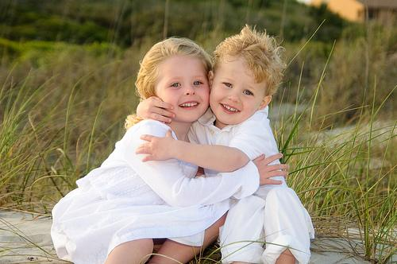

TASK: List 5 specific things an adult can do to support a child’s emotional and social development.
- ______________________________________________
- ______________________________________________
- ______________________________________________
- ______________________________________________
- ______________________________________________

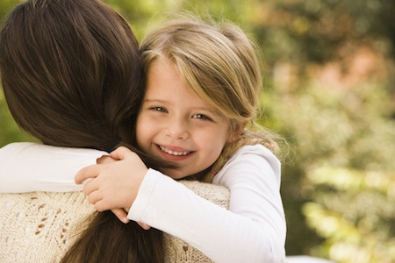

KEYWORDS
PROXIMITY: The nearness or close physical distance between the adult and the child.
TRANSITIONS: Long or short-term changes that affect the child’s life, eg: starting pre-school or changing carer.
EMOTIONAL SECURITY: A feeling of being cared about.

